# **User Guide**

**How to run and access the app**

Run the app.py file in order to start the app. The web application can be accessed by visiting the following URL, <http://localhost:5000>

**Homepage**

Will teach you about the different types of security attacks. Followed by a short quiz to test you on what you have learned.

**Ciphers demo**

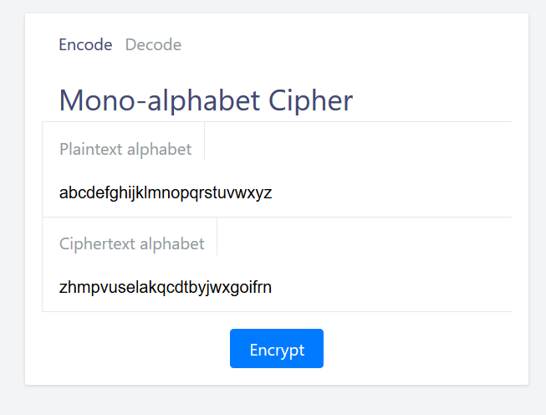

You will be able toggle between encode/decode mode. In encode mode, you will be able to encrypt plaintext into cipher text. In decode mode, you will be able to decrypt cipher text into plaintext.

**Ciphers demo – Decoding**

UI is pretty simple, all ciphers demo is following a similar design

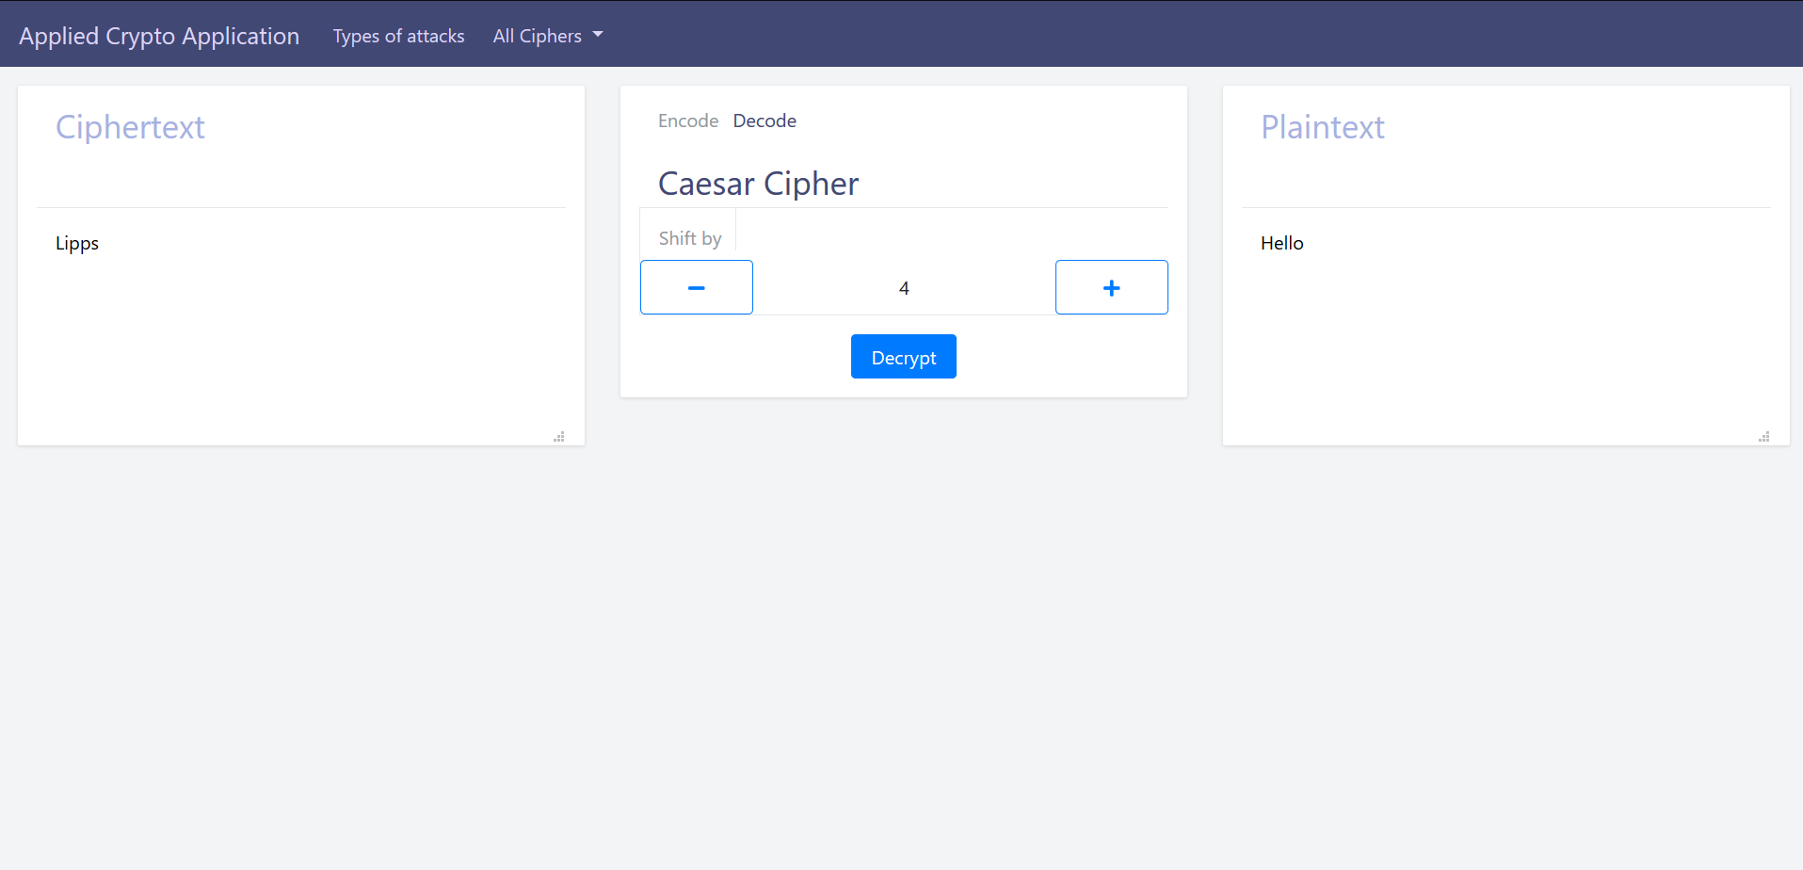

The box that shows the decoded plaintext

The box where you specify the settings of the cipher.

In this case it’s the no. of letters to shift by

The box that shows cipher text you are trying to decode

Step 1, Enter the cipher text you are trying to decode in the box labelled “Ciphertext”

Step 2, Specify the settings of the cipher, e.g. no. of rows, no. of letters to shift by.

Step 3, Press the “Decrypt” button, the output will be displayed in the box labelled “Plaintext”

**Ciphers demo – Encoding**

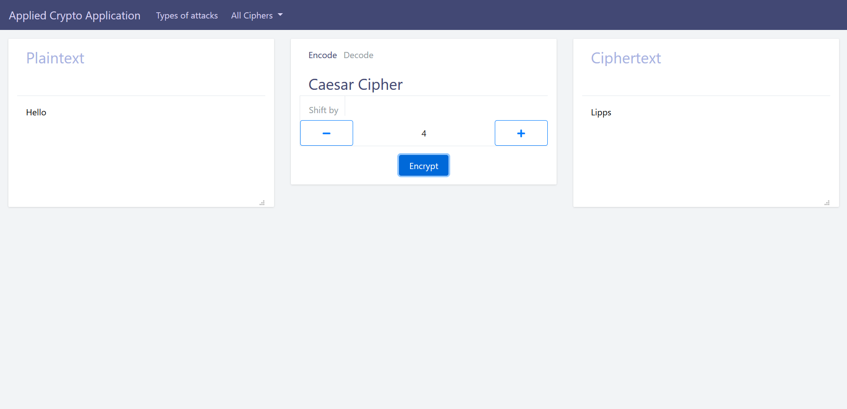

The box that shows cipher text output by the cipher

The box where you specify the settings of the cipher.

In this case it’s the no. of letters to shift by

The box that shows plaintext you are trying to encode

Step 1, Enter the plaintext you are trying to encode in the box labelled “Plaintext”

Step 2, Specify the settings of the cipher, e.g. no. of rows, no. of letters to shift by.

Step 3, Press the “Encrypt” button, the output will be displayed in the box labelled “Ciphertext”